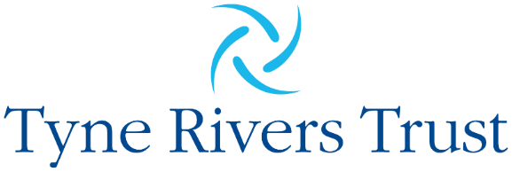
Better River, Better Region, Better Life

Tyne Catchment Officer

Salary: £35,000(FTE)/£28,000(PTE)per annum
Work Pattern: 30hrs/week
Working Arrangements: Flexible office/home based
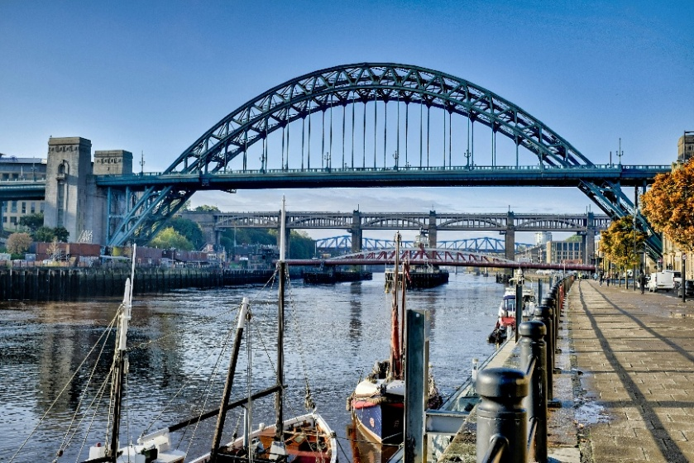
Contract Length: Until 31st August 2027 with ambition for extension

The Trust
We are Tyne Rivers Trust, the only environmental charity dedicated to looking after the iconic Tyne and its tributaries. We work to improve our rivers through conservation action and engagement.
The Tyne and its tributaries flow through picturesque semi-rural counties of Cumbria, Durham and Northumberland. A mixture of beautiful wide-open spaces, rich ravines and fascinating industrial heritage.
As the health of our rivers moves up the political and social agenda and the frequency and intensity of storms we are exposed to increases, the importance of our environment and how we live within it has been highlighted. Our work with partners is increasingly recognised for its crucial role in safeguarding our rivers for the benefit of our environment, economy and the health and wellbeing of everyone who lives in and visits the area. This is an exciting chance to use your skills, experience and passion to play a key role in bringing partners together to achieve more collectively.

The Role – Tyne Catchment Officer
As Tyne Catchment Officer, you will host the Tyne Catchment Partnership. You will be central to helping us achieve our vision by bringing together partners, stakeholders and communities across the Tyne catchment. In so doing, you will support our understanding of the issues impacting the Tyne and its tributaries and support the implementation of a catchment-based-approach to prioritise and implement the solutions.
The role is co-funded by Northumbrian Water and the Environment Agency and you will be responsible for ensuring the Tyne Catchment Partnership collectively delivers a range of Success Measures agreed by the partnership. Subject to the success of this, there is potential for continuation funding beyond the existing contractual deadline from either these sources or alternative options. These will be explored with you when in post.

Role Purpose
- Work closely with the CEO, Chief Scientist and Technical Director and TRT team to coordinate and lead the Tyne Catchment Partnership
- Develop strong relationships with stakeholders across the Tyne catchment, including sub-catchments, neighbouring catchments, and community groups.
- Organise and facilitate partnership meetings, support subgroups, and ensure effective reporting and governance.
- Maintain and develop the Tyne Catchment Plan, Integrated Catchment Plans for subcatchments, and a pipeline of projects and investment opportunities.
- Oversee the refresh of communications platforms, deliver an annual impact report, and contribute to TRT’s wider communications and reputation.
- Identify and create opportunities for funding, investment, and collaborative approaches to maximise impact.
- Contribute to fundraising, organisational development and delivery of TRT’s vision, mission, and values.

Person Specification: Essential
- Understanding of partnership working and the roles of charities, public bodies, businesses, and communities in achieving environmental outcomes;
- Excellent written and verbal communication skills, with experience producing reports and materials for varied audiences and the ability to adapt messages for technical, public, educational and community contexts
- Skilled in building and maintaining productive relationships, confidently facilitating inclusive meetings, and promoting consensus, collaboration, and co-funding opportunities.
- Highly organised with strong project management abilities, capable of managing multiple priorities and deadlines; proficient in Word, Excel, and PowerPoint.
- Diplomatic, approachable, and proactive team player with flexibility, initiative, and a genuine passion for rivers, the environment, and community engagement
- Experience of inputting data into CRM/data management systems and keeping all relevant information up to date relating to your area of work
- Full drivers licence

Applications
If you do not meet all the criteria but are still motivated by the role, please get in touch. We believe the most important thing is the person and their attitude and are keen to hear from you.
More information on the role is available in the Job Description. To discuss the position in more detail, or for a general discussion about working at TRT, please contact their Chief Scientist and Technical Director, Dr. Jack Bloomer, on 07939 317874 or j.bloomer@tyneriverstrust.org.
To apply, please submit a CV and covering letter demonstrating your ability to fulfil the role to Jack Bloomer as above.
Tyne Rivers Trust works across a large catchment, diverse in its inhabitants and their needs. We are committed to being an inclusive organisation. As an equal opportunity employer, we welcome your background, experiences and thoughts as an individual to deliver the best work we can as a team. Should you need support with your application please contact us.
Deadline for applications is 5pm 14th November 2025 with interviews scheduled for 26th and 27th November.

